DYNAMIC BUSINESS DASHBOARD - STEP BY STEP
Follow the following steps to create a DYNAMIC BUSINESS DASHBOARD

- 1️⃣ Gather your business data.
  - ✅ Business data available in Sample-Superstore.xlsx ➡️ Orders worksheet.

- 2️⃣ Creation of required Pivot Tables and Pivot Charts.
  - ✅ Go for Tab Data ➡️ Group Data tools ➡️ Analyze Data create following "Pivot Tables" and "Pivot Charts" in separate worksheets.
    - ☑️ Total 'Profit' By 'Region' in Doughnut Graph (ProfitByRegion).
    - ☑️ Total 'Sales' by year and month of 'Order Date' in Clustered Column (SalesByYearMonth).
    - ☑️ Total 'Sales' by 'Ship Mode' in Bar Chart (SalesByShipMode).
    - ☑️ Total 'Profit' by 'Customer Name' in Line Chart (ProfitByCustomer).
    - ☑️ Total 'Sales' by 'Sub-Category' in Pie Chart (SalesBySub-Category).

- 3️⃣ Create a new "Dashboard" worksheet.
  - ✅ Create a new worksheet "Dashboard"
  - ✅ Copy all the five "Pivot Charts" to this worksheet, and then rearrange and resize and place them.
  - ✅ Go for Tab Page Layout ➡️ Colors ➡️ Orange Red
  - ✅ Go for Tab Page Layout ➡️ Background ➡️ Bing Image Search ➡️ Search for "Paper" ➡️ Brown Paper
  - ✅ Enable "Data Labels" to all Pivot Charts.
  - ✅ Put the proper background color and required formatting to all Pivot Charts.
  - ✅ Do the needful for all currency formatting.

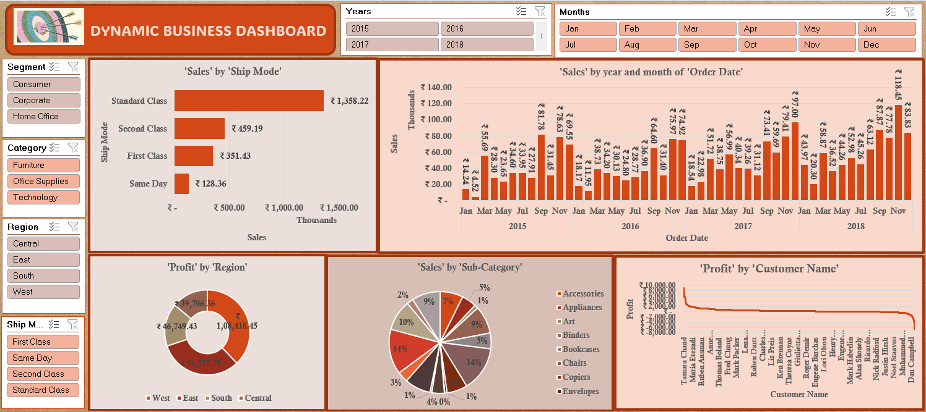

- 4️⃣ Dashboard Caption.
  - ✅ Go for Tab Insert ➡️ Shapes ➡️ Rounded Corner Rectangle.
  - ✅ Put the proper color, caption "DYNAMIC BUSINESS DASHBOARD"
  - ✅ Insert a Logo Image (Logo.jpg) in that shape.

- 5️⃣ Insert Slicers.
  - ✅ Insert following Slicers.
    - ☑️ Insert Slicer on attribute Segment (Left Top-1).
    - ☑️ Insert Slicer on attribute Category (Left Top-2).
    - ☑️ Insert Slicer on attribute Region (Left Top-3).
    - ☑️ Insert Slicer on attribute Ship Mode (Left Bottom).
    - ☑️ Insert Slicer on attribute Years (Top Middle).
    - ☑️ Insert Slicer on attribute Months (Top Right).
  - ✅ Establish "Report Connections" of all the six "Slicers" with all five "Pivot Charts".
  - ✅ Format and align all the six "Slicers"



- 6️⃣ Test the Dashboard.
  - ✅ Test the Dashboard in all respect and make it more effective and presentable.



